**Step 1: At the top of this cookbook, before the other resources that we have defined, we can read in the "apt" default recipe by typing**

# vim /home/ubuntu/chef-repo/cookbooks/apache2/recipes/default.rb

include_recipe "apt"

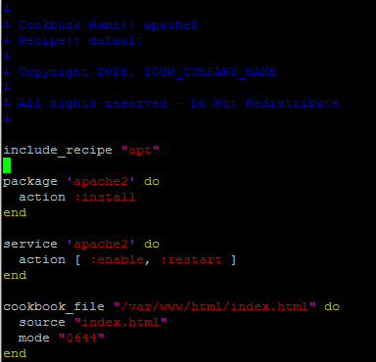

**Step 2 :Edit metadata.rb**

# vim /home/ubuntu/chef-repo/cookbooks/apache2/metadata.rb

depends "apt"

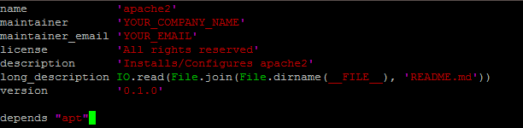

This file is checked when the Chef server sends the run-list to the node, to see which other recipes should be added to the run-list.

## **Step 3: Upload Cookbook to chef-server**

# knife cookbook upload apache2

Note : You should receive an error

## **Step 3: Upload apt cookbook and then apache2**

# knife cookbook upload apt

# knife cookbook upload apache2

**Tips : ENusre : you are in /home/Ubuntu/chef-repo ( when your un upload commands)**

**Step4.A) :** **Alternatively to check from command line on what cookbooks are uploaded on cehf-server**

# knife cookbook list

After we install the service, we probably want to adjust its current state on the node.

